**Spike:** Spike No. 2

**Title:** Task 7 - Performance Measurement

Author:Khang Trinh - 102118468

# Goals / Deliverables:

The goal of this spike is to learn how to test code, identify performance issues and make improvements where needed.

# Technologies, Tools, and Resources used:

* Visual Studio 2017
* Microsoft Excel

**Useful Links:**

<https://www.youtube.com/watch?v=x2niMA5tzGo&ab_channel=YunusKulyyev>

It's tiresome to manually enter each individual output like a non-lazy person :D

# Tasks undertaken:

### Step 1. Learn how to measure the time a function takes to execute

To do that, we need to know about std::chrono. In short, it’s a library used for time tracking.

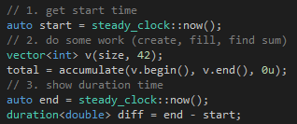

### Step 2. Learn how to do csv output.

It’s fine manually entering data into an excel sheet for a test if it only has 10 or so cycles, but if you’re testing in the millions, then you’d need a more efficient way, and one of which is letting the program do that itself.

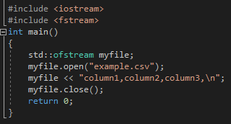

### Step 3. Stress test using for loop

A reminder to put your output and timer code *inside* the loop to time each operation as well as outputting the result into the csv file. The number of loops



### Step 4. Convert the csv output into a readable graph

There are different types of tests you may be asked to perform. Make sure that when it comes to plotting the data into graphs that you choose the suiting graph type to match the data.

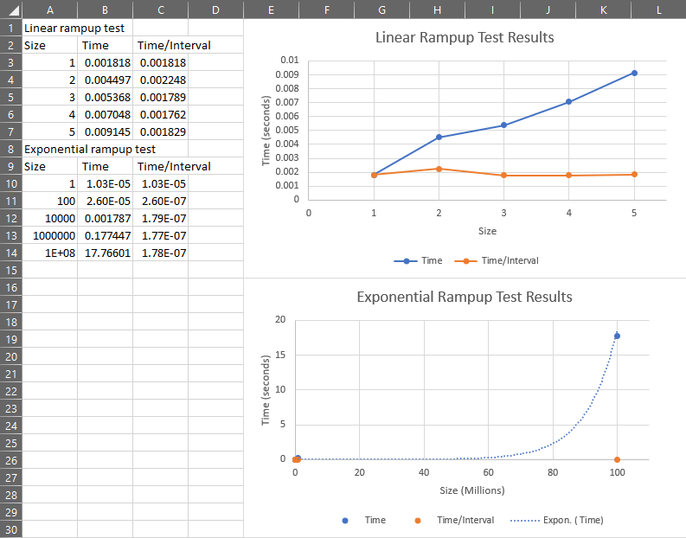

### Expanded version of the code as an example

